**Institute of Technology Tallaght,**

**Department of Computing**

** **

**INDUSTRY PROJECT**

**for the**

**BACHELOR OF SCIENCE (ORDINARY) with IT MANAGEMENT**

**a business Analysis of Incident Trends**

**A project report submitted in partial fulfilment of the requirements for ITT Dublin’s Bachelor of Science Degree (Ord.) in IT Management**

**By Ramona Valentine X00114375**

**Signed: ­­­­­­­­­­­­­­­­­­­­______________________________ Dated: __________**

**Supervisor: Patricia Magee, Lecturer of ITT**

**Submission date: Friday 3rd June 2016**

**Word Count: 8,973**

**CONTENTS**

**Project Title: “a BUSINESS ANALYSIS of Incident Trends”**

**Table of Contents**

**List of Figures 5**

**List of Tables 6**

**Abstract of Work Placement 7**

1. Aims 7
2. Objectives 7

**Organisation 8**

**Chapter 1 – CareWorks Background and Strategic Objectives**

* 1. Mission 8
  2. Background 8
  3. Investment 10
  4. Technology 11
  5. Management structure of the company and the role 11
  6. Strategic changes in Support department and team 13
  7. Interviewing other departments 14
  8. Support Team and Interviews 15
  9. Strategic challenges faced by CareWorks 17

**Chapter 2 – Critical Evaluation of Work Undertaken at CareWorks**

* 1. Work (Access/My role) 21
  2. Critical Evaluation 23
     1. Application of academic knowledge 23
     2. Formal and informal learning at the host organisation 23
     3. Future career plans 25

**Chapter 3 – Mini Project Write-up**

* 1. Mini Project Abstract 26
  2. Research 26
     1. How Data Is Taken 26
     2. What Communication Gap Means 27
     3. Tools and Methodology 29
     4. Internal and External documents 31
     5. Business process of the work carried out 31

3.3. Stages of analysis 36

* 1. 1. Current stage of data analysis 36
     1. Midway stage of data analysis 42
     2. End stage of data analysis 44
  2. Team Statistics 46
  3. Impact analysis on the business 51
  4. Recommendations for Improvement of Incident Trend Analysis 52

**Chapter 4 – Mini Project – Conclusions and Recommendations**

* 1. Conclusions 54
  2. Recommendations 55
  3. Other further research and investigation 56

**Glossary** 57

**Appendices**

1. Mini Project Proposal – Option 1 59
2. Induction Plan for Intern 62
3. Business Process Analysis and Improvement Strategy Plan 2016 63
4. Performance Plan and Review 66
5. Presentation Slides 70
6. SWOT 71

**References** 72

**Bibliography**  72

**LIST OF FIGURES**

Figure 1: CareWorks’ website (careworks.co.uk/company, 2016) 10

Figure 2: CareWorks’ Management Structure of the company (internal, 2016) 12

Figure 3: Customer access CareWorks Service Desk Portal (careworks.co.uk/company, 2016)

21

Figure 4: Photo of wheelchair user on computer (internal USA, 2016) 25

Figure 5: Snapshot of graph with incidents over two years (internal, 2016) 27

Figure 6: Incident Management Process without ITIL diagram (Carmody, 2014) 32

Figure 7: Sweeping up the incidents process plan (internal, 2016) 33

Figure 8: Taken from website: <https://www.optimizesmart.com/how-to-become-champion-in-data-reporting/> (Optimize Smart, 2011) 35

Figure 9: Snapshot of graph with incidents over two years (internal, 2016) 36

Figure 10: A number of Status Reasons listed for the stage an incident is at (internal, 2016) 40

Figure 11: Midway graph pattern trend (internal, 2016) 43

Figure 12: Trends Analysis of Communicated Incidents (internal, 2016) 44

Figure 13: Final project analysis (internal, 2016) 45

Figure 14: Incidents By Status Reason (internal, 2016) 46

Figure 15: Cases by Priority (internal, 2016) 47

Figure 16: Incidents By Customer (internal, 2016) 48

Figure 17: Incidents Approach SLA Breach (internal, 2016) 48

Figure 18: Service Leaderboard (internal, 2016) 49

Figure 19: Case Mix, By Type (internal, 2016) 50

**LIST OF TABLES**

Table 1: Open and Closed incidents trend table comparison to 2014 (internal, 2016) 38

Table 2: Levels of Priority incidents trend table comparison to 2014 (internal, 2016) 39

Table 3: Two areas of the project’s aim and objective (internal, 2014) 42

Table 4: Two areas of the project’s aim and objective (internal, 2016) 42

Table 5: Midway data (internal, 2016) 43

Table 6: End of data (internal, 2016) 46

**ABSTRACT**

**OF WORK PLACEMENT**

**AIMS:** To complete a 3rd Year Work Placement, with an Industry Project based on Incident Trends Analysis

**OBJECTIVES:** To gain knowledge and understanding of types of IT roles in the Information Technology industry such as Service Desk

This report will cover the roles and responsibilities of the Service Desk and the types of incidents that are logged in. As the Service Desk is the first port of call, it is known as “First Line” or “Level 1”. The incidents get screened before assigning it further up the next level to “Level 2”, depending on the nature of the incidents. It is from here the project had been decided to be based on the overall of the incidents management.

For this project, I will be looking at the number of incidents that are logged into CareWorks’ Service Support Desk whilst in my work placement capacity. It willdetail the reasons of trend patterns behind the incidents logged. Also, identify that customers need further help with managing their social care systems through CareWorks’ software applications. I will analyse the current stage that the Service Desk is presented as of, 1st Feb 2016, and follow through until my seven-month internship contract ends on 26th August 2016. I can use the available information required for my analysis and to compare with previous data analysis. My role will mainly be “sweeping up the incidents” so that the increasing volumes of incidents are reduced as much as possible. Finally, I will present my key findings through my recommendations and a future projection of CareWorks in my project report, as well as, presenting this to the team at CareWorks. A presentation will also be made at the Institute of Technology Tallaght on 8th June 2016.

**ORGANISATION**

**CHAPTER 1 CAREWORKS BACKGROUND AND STRATEGIC OBJECTIVES**

**MISSION:** CareWorks’ mission is to provide solutions to organisations that serve, engage and enable patients, and people in need (internal, 2016).

**BACKGROUND**: CareWorks was established in Ireland in 1997 as the first social care systems and software company to offer a social care management tool solution, based on world leading CareWorks customer relationship technology using Microsoft Dynamic CRM (see Figure 1, 2016). Their vision is to focus worldwide on organisations that provide health and social services. Their solutions address a set of common needs identified across the world. CareWorks’ use case management are used through mobile and portal technologies for the providers, carers, public and funders. They can deliver better and ensure it is cost effective to consistent manageable outcomes of their caseloads.

They have designed and delivered social care case management solutions for the following local authorities and government bodies:

* Criminal Justice and Youth Justice
* Children’s Services:

Integrated Children’s System

Children in Need

Looked After Children

Adoption

Child Protection

Leaving Care

Common Assessment Framework

* Adult’s Services:

Single Assessment Process

Mental Health

Self-Directed Support

Most of their clients are from the UK as well as the USA and Ireland. They partially cover India and are currently planning on expanding the business into Singapore. CareWorks consider themselves to be known as social care specialists with more than 15 years’ experience. CareWorks currently have more than 75 local government customers, over 20,000 customers and have completed over 100 installations (internal, 2016).

CareWorks have been recognised for their Award-winning technology and received the NHS Health and Social Care Award 2009 (joint winner) in the UK’s regional final. The company was also a finalist in the NHS Public Sector Health Partner of the Year Award 2009. In relation to the use of Information Technology, CareWorks apply the principles of Customer Relationship Management to the world of social care systems.

Figure 1 shows the company’s home page on the website (careworks.co.uk/company, 2016).

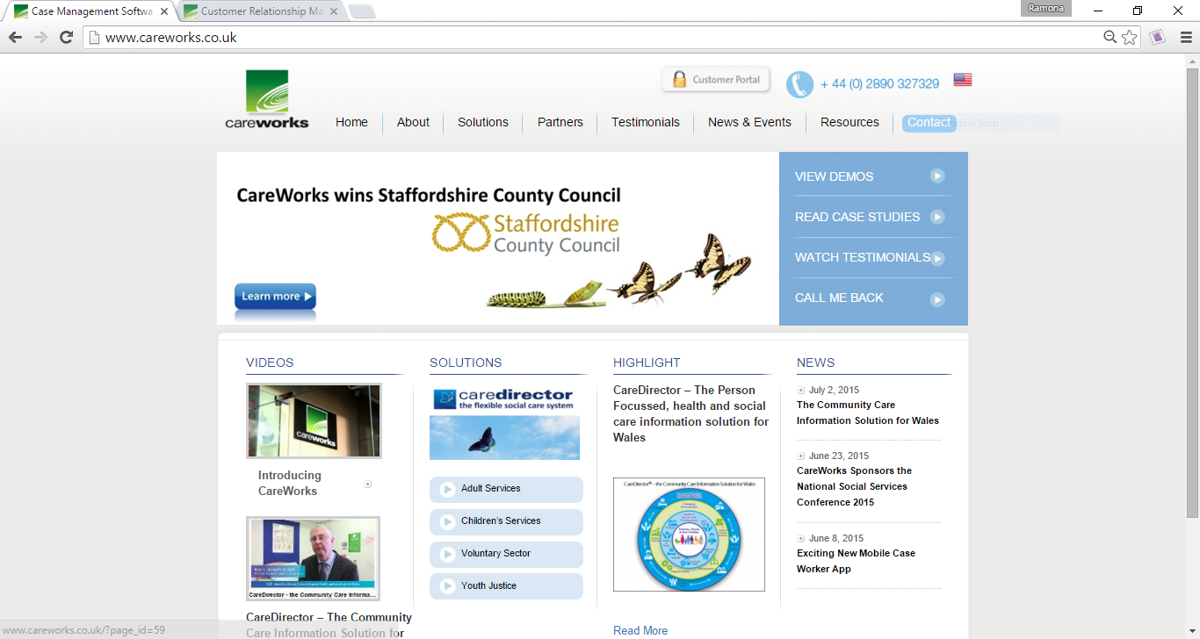

Figure 1. CareWorks’ website (careworks.co.uk/company, 2016)

**INVESTMENT**

CareWorks currently invest in markets, in the USA, for:

* Disability Providers
* Managed Care Providers
* Aging and Disabilities Services

Here, the opportunities are focused on home and community based services with modular and mobile solutions which are provided by government entities and by external providers (internal, 2016).

CareWorks currently invest also in the UK market and in particular the NHS for integrated Health and Social Services systems to regional Health Trusts as well as Local Authority Social Services departments.

Their future plan is they will continue to invest on recruitment and training in each country as well as marketing their products.

**TECHNOLOGY**

CareWorks will:

* Build and release a version CRM 2011 that is compatible with Internet Explorer 11.
* Achieve MS SQL Server 2012 and MS SQL Server 2014 compatibility
* Windows 8 compatibility including Outlook
* Upgrade to MS CRM 2016 in June/July 2016
* Mobile Web App will be launched late 2016

**MANAGEMENT STRUCTURE OF THE COMPANY AND THE ROLE**

**OF THE EMPLOYEE WITHIN THE COMPANY**

My role as an intern fits under the Support Manager, who works directly under the Chief Executive Officer (CEO). There are seven departments under the CEO. They are split into:

* the USA area;
* Development/Implementation Teams (Backend);
* Support Service Desk (Frontend)/Engineering;
* Sales/Project;
* Payroll;
* Administration
* Marketing.

The company also employs staff on a contract basis for 12 months or shorter depending on requirements.

Figure 2 shows the management structure of the company and their role titles (internal, 2016).

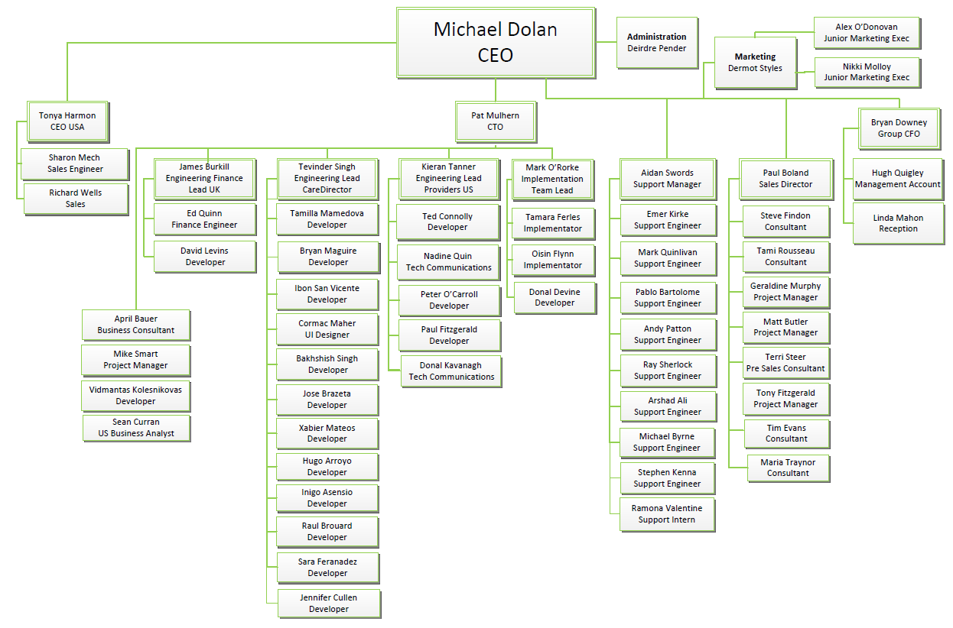

Figure 2. CareWorks’ Management Structure of the company (internal, 2016)

**STRATEGIC CHANGES IN SUPPORT DEPARTMENT AND TEAM**

The role of IT and the use of Information Technology in the department follow a predefined system process. The support department sits in at the frontend supporting clients who log incidents with the company. My key role is to serve as the first point of contact between the customer and the company. Details of which include:

* Screening each incident and verification of details such as priority, product, version, environment and module.
* Deciding who to assign the incident to.
* To see if I can resolve incident on my own merits.
* Otherwise I assign it to the next level 1 resource and if he cannot then he pass it onto the next appropriate level 1.
* Escalate incident to level 2 after reproducing the steps

Recruitment of another full time level 1 staff was on the agenda, but due to busy schedules, recruitment was put on hold. At the time of writing this Chapter 1, we lost a level 1 team member which resulted in his 280+ incidents being split between four team members, including me.

The tasks that I set myself to do are:

* To familiarise myself with the connectivity issues and the common Information Technology issues customers are having.
* to reproduce issues that customers logged
* to identify issues that are of a similar nature
* to identify any bugs in the CRM system
* to recognise Critical, High, Medium or Low priority setting

The Manager continues to recruit two full time posts for the support team. This will help to reduce and manage the incidents once a full team is in place.

There was a review of the incident management and the support team as the incidents increased significantly since a new staff member has joined the team. The dynamic situation had to be reassessed and changed. My role in assigning incidents process now goes to 1st level 1 team member.

**INTERVIEWING OTHER DEPARTMENTS**

There is one overall business objectives plan for all departments that is held by the CEO (internal, 2016).

I emailed and set up selective interviews to meet with:

* + Support Manager – Support Team
  + Engineering Lead – Development Team
  + Project Manager – Sales Team
  + Implementation Team Lead – Implementation Team
  + Support Engineer – Support Team
  + CEO

At the time of uploading Chapter 1, I was able to organise between three to four interviews as it was a very busy period and so not everyone had time to be interviewed by me. By the end of this work placement I hope to gain further understanding of their roles in each department relating to their respective roles and responsibilities of contributing to Information Technology and to understand that each individual plays a major part in the carrying out of troubleshooting IT issues and providing solutions.

**SUPPORT TEAM AND INTERVIEWS**

**Support Manager**

The Support Manager reviewed my list of competencies and objectives to establish who else would be the ideal person to refer to in order to meet and complete my requirements. I received great support with regards to my learning outcome needs and especially around the mini project (refer to Chapter 3 in this report). The Support Manager has assured me of their full support on the business analysis project. It was his responsibility to identify the incident trends and to observe patterns until I came along where he was happy for me to continue for my mini project. I have to learn how to evaluate and interpret what the trends are telling us. I will be comparing three stages which are current, midway and end stage.

The Support Manager deals with complaints from senior level customers who can pose challenges in terms of questioning how CareWorks operate. He then would have to discuss with level 2 and level 1 (sometimes) that if any incidents that are raised by them are closed off. He would also advise the Chief Technology Officer (CTO) who works directly under CEO and explains the reason for the incident being closed off. He also requests Payroll to bill them for the unnecessary time spent. The CTO would then have a conversation with the account client and see if an agreement can be reached.

**Project Manager**

It was not possible to interview the sales team during this phase of the report but the project manager did provide me with useful documentation.

Her roles and responsibilities are:

* Liaising between customer and CareWorks to see the project go smoothly
* Taking all the suggestions from pre-Contracted customers
* Ensuring the Service Level Agreement (SLA) is not set yet
* Ensuring Test and Live timelines are on schedule
* Providing post-Implementation support for two weeks after release
* After release, incidents should not come in as Critical and the date of SLA will take place
* After two weeks have passed, all incidents will be treated like other incidents
* The Project Manager will no longer be involved.

**Support Engineer**

I, alongside the Support Engineer observed:

* how to restore databases
* backing up databases
* how to apply Structured Query Language (SQL) queries through SQL Management
* how to word certain responses when communicating to customers

The majority of raised issues are regarding the connectivity, customers’ concerns over scheduled dates for backups, installations, upgrades and release of fixes. From shadowing the engineer this week, I found his role quite interesting.

From what I learnt from the engineer, the application, database and warehouse servers sit in Test and Live environments. I also got to see how the SQL queries were being applied here. For example, “select * from version” (internal, 2016), which bring up a list of all versions on the customer’s servers.

**Chief Executive Officer (CEO)**

The CEO helped me with the following information during the interview about the strategic challenges faced by CareWorks. Due to confidentiality he is not in a position to provide me with information on financial costings and I agreed this would be fine (internal, 2016).

The system process for CareWorks works like this (numbers are in order of process):

|  |  |  |  |
| --- | --- | --- | --- |
| 1. 1. | 1. Specification | India + UK  US | Use case with US/UK consultants and Business Analyst |
| 1. 2. | 1. Development | Customers | Sprint reviews |
| 1. 3. | 1. Testing | Indium | Systems Test (Indium scripts) |
| 1. 4. | 1. Customer Testing | U.A.T. – User Acceptance Testing | Customer scripts |
| 1. 5. | Live | | |
| 6. | The following people deal with customer side are the Project Managers | | |
|  | The cycle goes back to Testing if there is a recheck after a change – this can take a while. | | |

**STRATEGIC CHALLENGES FACED BY CAREWORKS**

The information in this section was from my interview notes during the interview with the CEO.

CareWorks’ Business Strategic Plan is based on a 2015-2018 (three-year plan). It includes departmental plans. CareWorks noticed the social care industry were getting increasing amount of public information added to their social care work during the last eight to ten years. This is due to family breakdowns during recession which in turn increases the number of depression and other mental health issues. A long list of physical, emotional and financial abuse is causing the social care industry to be put under immense pressure. This in turn means more expectations are expected from the software application tool.

More support required from people coming up on the radar so the software solutions this company provides have had to increase various customised functionalities for respective client accounts. The demographics of older generation have increased and in the UK, the Government made a 20% cut back on budget allocations. This puts an increasing level of pressure on clients to manage their caseloads in social care.

It is therefore crucial to provide a managing support tool to help social care with shortage of staff. The company offers a mobile working environment which helps to support a more efficiency management caseload by accessing records whilst out on the road. They use a Mobile Web App.

The NHS is a protected by the government which means the local authorities can gain 100% government backing support within the community. This would affect the increasing number of admissions in social care and hospitals. Both of which would prefer to keep patients at home rather than in institutions and hospitals.

CareWorks also made a stamp in the segment of the US market. There is a 20% recurrent revenue from there. The base is relatively new although it has been established for a few years. The company is small, increasingly expanding, therefore, CareWorks have not concentrated on moving forward as much as they should. There is a lot of work to be carried out over there especially in research on customers’ market, customisation of the social care management tool and use of product innovation. CareWorks are looking at solution ideas for major innovation projects. They have yet to work on these for customers in USA. With the pilot ones in UK and in Ireland they have some concrete ones in places and will do the same in USA. The business models in the USA is a SAAS based approach and in the UK it is a licence based approach.

There is a possibility to expand the business into Singapore however the work there together with the cultural differences requires more respectful consideration and although they have put in their tender it is too much at the moment to handle but will remain in the pipeline.

One of the major issues in other countries is the legal aspect of the health standards. CareWorks have their own regulations based on the ISO 27001 EU and under USA, for example, USA’s Information Security implementation – HIPAA (EU equivalent). The authorities from different countries have to come to an understanding.

There are teams based also in India and Spain. These countries help to manage a process to promote and launch their products which includes the flexibility to scale-up and scale-down.

Regarding the recurrent revenue for new and existing contracts, it is planned after a five-year period, a decision will be taken as to whether to renew the contract or not. The longest and the oldest contract on the book is 20 years with a client. The shortest one is 3 years but on average, most stay on for about 10 years with CareWorks (internal, 2016).

**CHAPTER 2 – CRITICAL EVALUATION OF WORK UNDERTAKEN AT CAREWORKS**

Figure 3 shows the home page of Service Desk for customers where they raise incidents for CareWorks’ staff attention (2016).

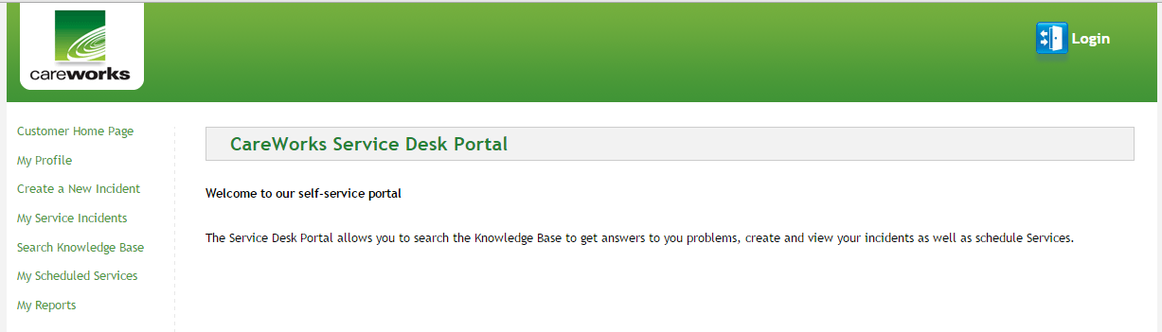

Figure 3. CareWorks Customer Service Desk Portal (careworks.co.uk/company, 2016)

**WORK UNDERTAKEN**

Description of my role and tasks during the seven-month internship:

**ACCESS:**

* Support SharePoint page
* MS Dynamic CRM – main focus as this is where incidents are viewed and logged
* Service Desk
* Technical Communications
* Customer Portal
* Mindsalt (time recording timesheets)
* Skype (for Business)
* Outlook

**MY ROLE:**

* Create new documentation or amend existing documents
* Creating and interpreting changing trends of weekly reports at the end of each week
* Highlight the value of communication to customer and the dangers of satirising
* Self-allocation of new incidents, change status to ‘In Progress’ and complete other fields, then assign to the support team
* Evaluate the incident, suggest what the initial response should be; certain customers may react negatively to certain types of responses
* The main focus initially is on customer service. My remit is to sweep up the incidents after the team. I should ensure all escalated incidents are communicated to after 2-3 days. Use the CRM views and figure out how best to identify the escalated incidents that need a communication.
* If the escalated incidents are no longer a priority, they should be unflagged for escalation or closed off.
* Present any good ideas to the team and implement to an agreed standard.
* Use of the standard response template for communication to customers. Reword appropriately and not just copy/paste each time.
* Review and understand the 3 strikes and you are out chase up process
* Distribute the follow ups 3 steps review with follow up communication
* A project, if required, would be good if focused around the incidents analysis trending patterns.

**CRITICAL EVALUATION**

**APPLICATION OF ACADEMIC KNOWLEDGE**

I learnt how the connections between the Servers interact with the customers’ when they log into our Server at CareWorks through the self-service portal. I gained understanding of the different URLs for Test and Live environments on different servers. In order to check the versions, I observed the Engineer carrying out the testing by using Structured Query Language (SQL) queries. I also noted that the SLA was crucial and was of more relevance when working on the incidents. As a result of learning about SLA (2014), recognising http, sending / acknowledging request; retrieving data from a Database server to send back to customer over the Transmission Control Protocol (TCP) in college, I understand the relationship between the programme modules and the function that I carried out during my work placement.

The modules I have studied in college that I have found beneficial in my work placement are:

* Database – all levels
* Operating Systems – all levels
* Computer Services Management – SLA, ITIL, ISO, Framework/Models
* Object Oriented and Systems Analysis and Design – Use Cases
* Software Quality Assurance and Testing – system process etcetera
* Cloud Distributed – architecture
* Web – all levels

**FORMAL AND INFORMAL LEARNING AT THE HOST ORGANISATION**

The areas that were of a delicate nature included items such as obtaining company’s policies around Security and Business Strategic Plan. A limited number of key staff members had access to certain materials. I used Outlook to email and Business Skype to send instant message to staff for specific information required to complete any part of my competencies and to ask if I could observe, support or participate in their projects. This was not possible most of the time so I had to liaise with my Support Manager who was very supportive. If I could not get what I needed he will create one or find one himself and give it to me to try out or use it for my report. I would be given a spare pc to do a dummy run on that. Any questions I had were raised with the team.

I also set up three interviews with the external team – project management and engineers to recognise their input to the CareWorks business plan. The staff were very accommodating and supportive once I mentioned that I am an Intern. Through this I was able to tick off other competencies which I had completed through my interviews and through my participation on some of their projects. I requested to meet a multi-disciplinary team and see how their inputs produce successful outcomes, but unfortunately due to time constraints this was not possible.

I set up my Performance Plan in order to show my Manager what I need to learn and to be able to demonstrate Information Technology issues. Whenever I learnt something new or understood how the role of IT operates within the company I made a note of it. I drew up some flowcharts for my next review meetings with my Manager. He suggested that I carry out presentations to get feedback from the team.

I suggested that I should see what problems customers have on applications from CareWorks, by replicating their steps so I could identify/troubleshoot any incident issues relating to that. All I needed was access to replicate the steps. This means I could take some incidents off the hands of others if I could resolve the issues, resulting in the closure of the incidents. I also recognised that the IT industry can open doors to people with disabilities as the role I was in was an office based job and a sit down all day, doing the troubleshooting IT issues. These present good opportunities for wheelchair users with IT background.

**FUTURE CAREER PLANS**

I know what I want to do after my work placement experience and I do not see myself in the future at the frontend of the IT industry in customer service especially Service Desk. I like moving around all day, not sitting down. I like to go from department to department configuring their IT devices. I would be happier in the backend carrying out testing applications, before going live and then training users on using same. This places an emphasis that the next step cannot be achieved until the last step was completed. I would prefer to be in a less SLA environment. Possibly teaching people of all ages and abilities is an option. I would also want to raise awareness to IT industries that a person with disability could perform programming, customer service or networking tasks. See Figure 4 of a wheelchair user on computer all day. Note the crutches by the laptop (internal USA, 2016). This person uses a computer and is a wheelchair user and has a very friendly customer attitude.

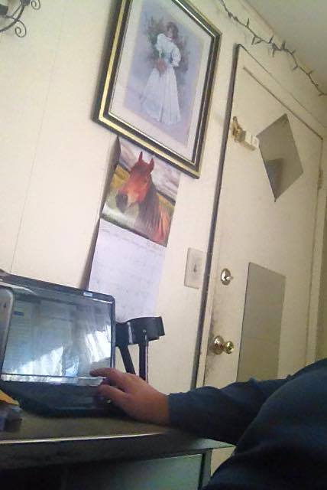

*(Copyright@2016 Kim Shaver)*

Figure 4. Photo of wheelchair user on computer (internal USA, 2016)

**CHAPTER 3 MINI PROJECT WRITE-UP**

**MINI PROJECT ABSTRACT**

**Aims:** To close the communication gap by resolving a number of incidents.

**Objectives:** To manage incidents more effectively and efficiently by analysing and

interpreting through the incident management process

The project is decided around incidents because my main role is the Service Desk. It was imminent I could focus on the incidents and use the data from here for my project on incident trends analysis. Information is taken to identify, what specific data are required to analyse the incidents and to review the incidents management process. The Support Manager and I would have frequent meetings at first and then monthly. We review the analysis from the previous week and highlight any key trends and address solutions to reduce to number of incidents logged in.

**RESEARCH**

**HOW DATA IS TAKEN**

Taking the data from the two areas:

1. Percentage of incidents that have been communicated to – this means each time an update (a communication) has been made to an incident, the length of time the overall number of **incidents, decreases**. So if an incident is not updated, the length of time the overall number of **incidents, increases**.
2. Average number of days since 1 December 2012 (management started collecting statistics on this date), incident has been communicated to – this means **the increasing AGE of incidents**, so the increasing number of days an incident was last updated, the less chance that an incident is closed off. It implies incident have been left floating. The **decreasing AGE of incidents** reflects higher chance to close off.

Figure 5 shows the current data graph (internal, 2016).

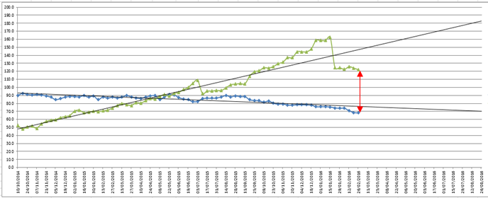

**Figure 5.** Snapshot of graph with incidents over two years (internal, 2016)

Some examples of content of reasons behind the ‘Status Reason’ field are:

* ‘Waiting For Customer’ - customer has not responded
* ‘On Hold – Pending Fix’ - this can take even up to two years
* ‘In Progress’ - still working on resolving the issue
* ‘Resolved – Pending Acceptance’ - customer refusing to close it off. There is an auto-resolved feature where it closes the incident after ten days. However, this does not always work so there are times where these are done manually.

**WHAT COMMUNICATION GAP MEANS**

In Figure 5, the further the two areas are widened, the less it is likely that the incidents are resolved and closed off. For example, an incident logged in, say in 2014, has still not been closed off. The reason was, that a customer is not satisfied that this incident has been resolved and so it remains open. Another reason is a lack of knowledge and a high level of complexity required, which can lead to no attempts by either party to follow up to resolve this incident. Therefore the increasing Age of the incident and decreasing (lack of) communication updates has widened the “communication gap”.

Throughout this report the graphs will have two lines representing these two areas. This report considers the nature of the incidents and will work out why the communication gap, involving both lines are not meeting towards the middle of the graph (in Figure 5). The two lines on the graphs need to meet and then cross over each other. This will indicate the increasing percentage of incidents are being communicated to and resolved. This results in satisfied customers and contracts being renewed for the long term. This also allows the support team more time to allocate on resolving complex incident issues.

The further two lines go away from each other, the wider the communication gap which makes it the harder it is to manage the incidents.

In order to carry out the project for this report a weekly routine is required to input the data from the Sharepoint dynamic Excel link in order to compare the data for the current week with the data from previous week. The figures of incidents are taken from the Microsoft Dynamic’s Customer Relationship Management (CRM). Part of the research is to take analysis from other tables in Excel and CRM and look at the different stages of the main support team. This team in particular has experienced a lot of changes, regarding staff resources. This has affected managing the incidents as well as the escalation of assignments to individual team members, a challenging process.

**TOOLS AND METHODOLOGY**

The tools I used are CRM, Excel (Pivot Table), shared documents on cloud and observations method. I have interviewed staff to see where they fit in with the relationship between customers and incidents. I will also combine my role as first level/line post to carry out the task of collating data for the internal weekly incidents metrics. My task includes reporting this data, every Fridays, for internal key staff. They can see how the support team is doing with the incidents so far. I included Key Trends and Analysis into my end of week reporting on the incident metrics.

I acquired data from other tables to help me with my research and analysis, which included the below:

* Total number of incidents in Support
* Closed incidents per week
* New incidents per week
* Average age of all incidents
* Open vs Closed incidents
* Average number of days since incident last updated
* Incident Trending (which includes the total of backlog and the average age for backlog and average age since last modified)
* Total backlog of Priority levels
* Incident communication information (percentage of incidents communicated to and average number of days since last communication)
* Root Cause Analysis

Then I looked at the Incidents Status:

* In Progress
* New
* On Hold - Pending Service
* On Hold - Pending Release
* On Hold - Pending Install/Upgrade
* On Hold - Pending Fix
* On Hold - Enhancement Request
* On Hold - Customer Request; Escalated – Technical
* Escalated – Candidate for Next Release
* Waiting For Customer
* Resolved - Pending Acceptance

In addition, I looked at the Root Cause Analysis of incidents that were closed off for whatever the reasons, example, Customer – Information Request or Closed – No response or Customer – Duplicate. Duplicate incidents logged in exact same issue meaning double time is spent if two team members pick up at different point.

**INTERNAL AND EXTERNAL DOCUMENTS**

The data would be taken from the CRM, non-closed incidents this week, auto-resolved not resolving and from the age fields. The age field shows how long an incident has been communicated to since it was logged in. Following an “Audit History” (it is like a paper trail of evidence) in CRM it will show no action has been made to this incident and the age will indicate if it has been days, weeks, months and even years. The CRM has a feature of auto alerts functionality which counts up days of no action/communication made on incident. I obtained information from other fields because I wanted to examine other areas that may be causing an impact and to eliminate any other root causes. I carried out a comparison analysis on a week by week basis and what other reasons had caused the changes on the incidents to escalate. The impact of the business remains on whether the incidents were closed off or remained open for a long time unnecessarily. It would reflect on how customers have been treated by the company when the company is trying to promote and inspire certain industries of their software products applications to their working environments. Customers may go to another company.

**BUSINESS PROCESS OF THE WORK CARRIED OUT**

Service Support and Service Delivery are considered to be at the heart of the ITIL framework for IT Service Management (Van Bon, Pieper, and van der Veen, 2015). Figure 6 shows the Incident Management Process without ITIL diagram taken from the lecture slide note on Capability Maturity Model Integration (CMMI) in Computer Services Management module (Carmody, 2014).

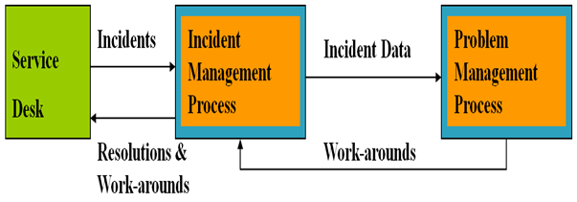

**Figure 6.** Incident Management Process without ITIL diagram (Carmody, 2014)

Objective of Incident Management - To return to the normal service level, as defined in the SLA, with smallest possible impact on the business activity of the company and the user (Carmody, 2014). See Figure 7 of a team plan called Sweeping up the incidents process plan (internal, 2016), where the plan is to reduce the number of escalated incidents. The graph demonstrates how the incident management process should appear in the end after each stage.

The activities involved in this process are:

* + Detection & Recording
  + Classification & first Line Support
  + Matching
  + Investigation and Diagnosis
  + Resolution & Recovery
  + Incident Closure
  + Incident Ownership
  + Monitoring
  + Tracking and Communication
  + Total Number of incidents closed
  + Average Resolution Time

The data trends analysis process I followed:

**Figure 7.** Sweeping up the incidents process plan (internal, 2016)

In order to view the whole picture or at least expand on the current stage I resorted to other materials outside the host organisation including from my college subjects, such as Business Information Systems, Computer Services Management and Software.

To refine the search I came across a set of rules (Optimize Smart, 2011), for analysing ‘data trends’ and reworded it all to reflect the examples during my work placement.

**Rule #1:** Always question how the data is collected as accurately as possible especially for the time period to analyse only. Why? Wrong goals can give incorrect and not accurate data values. Decision is relied on this data and can cause an impact to the business.

**Rule #2:** Historical data is in fact “dated” therefore it is unreliable and unrealistic. Things will have changed, so the timing of the duration taken is crucially important.

**Rule #3:** Select the right time period to analyse data trends. There could be a reason why the trend always go up at a particular time and down at another time. During interviews with Support Team it was noted that the summer period is quiet as less incidents are reported. Whereas in the winter, staff are indoors a lot of the time so they have the time to log in incidents with us hence the high peak of incidents that get called in. On this side staff could potentially be off sick with flu leaving the incidents increasing for staff during this period. Collecting data should be minimum three months rather than one month.

**Rule #4:** Add comparison to the data trends as this will make it more realistic and a better look at the picture of the comparison. It will help other departments, such as Marketing, get some insight.

**Rule #5:** Reporting standalone metric in data trends is not measurable so impossible to associate one unless another can accompany that. Metrics in data will calculate all the trends happening at that time. So in this project I used the last communication made to these incidents. I could have used other data.

**Rule #6:** Segment the data. When segmenting both data trends it will help to figure out the decline of one and the increase of another around the same period. This will show the influx of traffic of incidents and not being able to action on them during this time.

**Rule #7:** Report bottom line impact to business from these trends can help the director and the company to strategically plan out their areas of budgeting, staffing, equipment and training. They rely on these data trends to prove to others external to the company the business they run which in turn they can ask for clients to invest into their business.

**Rule #8:** Present the insight in reporting. Always when reporting the data trends to senior management and team the insight of 3-4 bullet points is useful to get a quick glance of current situation supported by the graph(s) thereafter. See Figure 8 where an example of how to be a champion in data reporting should be done (Optimize Smart, 2011). It is clear, concise and highlights visually without going into greater detail.

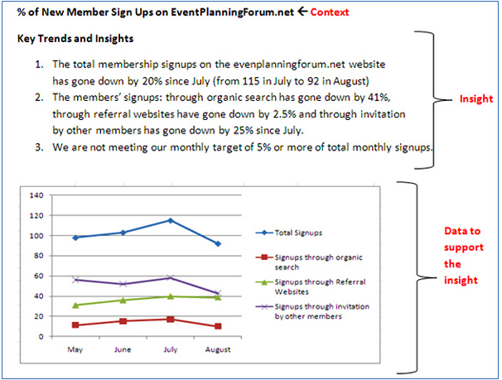

**Figure 8.** Taken from website: <https://www.optimizesmart.com/how-to-become-champion-in-data-reporting/> (Optimize Smart, 2011)

**STAGES OF ANALYSIS**

**CURRENT STAGE OF DATA ANALYSIS**

The current workload is very heavy and a team member had 280+ incidents assigned to him. Those remaining 80 incidents were split between two other team members.

Figure 9 shows the current data graph (internal, 2016) and the red arrow indicates the best it was at, since the start of February 2016. The graph dates from 10th October 2014 and was doing well. Then it crossed over around 3rd May 2015 and has since escalated. There was a time where the graph showed a good result for a few weeks around 3rd July 2015, however incidents have escalated again. A lot of incidents had already breached their SLAs.



**Figure 9.** Snapshot of graph with incidents over two years (internal, 2016)

The green line indicates ‘Average number of days since last communication (after 01/12/2012)’. – Age

The blue line indicates ‘Percentage of incidents communicated to’.

(See the meanings of these two areas under Aims and Objectives heading at the start of Chapter 3 in this report.)

Back in September 2015, the communications to incidents were not acted upon whilst the increasing number of incidents logging in was waiting to be resolved status. Usually, about 15 incidents would arrive. Since I was in place, there were about 42 incidents coming in daily.

The steps to take at Service Desk level (first port of call for screening all incidents) involve:

1. As the level 1 is first port of call and most of their tasks can actually troubleshoot IT issues BEFORE it is passed to level 2.
2. Only pass it on if level 1 is unable to resolve this issue after a couple of days.
3. However if the few incidents that come in and sit in the level 1 queue then they will have to wait a while before anything is achieved within a week.
4. If no other critical or high priority issues are raised, level 1 needs to sort these out first by checking with key staff member if this is critical / high or not.
5. If not, then level 1 will send out a message reminding customer why this priority has been changed to a medium or low depending on the nature of the query.
6. The other common area, is customers logging in an incident but have forgotten to attach a screenshot or a PSR (Problem Steps Recorder).
7. Level 1 will hold back the incident and get back to customer requesting a screenshot.
8. Sometimes the customers do not attach anything and assume that we can resolve issue without any image. They become irate with our request for this.
9. We would explain to customer why we are requesting this. We explain this so we can replicate the steps of the issue in order to resolve their incident.
10. We often get customers who do not know what a Problem Steps Recorder (PSR) feature is and again we reply and explain what this is. PSR is a recording technique that customer presses to record the clicks they made along the way until they receive the error message. The customer presses the stop recording button, saves this file and attaches it to their incident. This is useful for the company to be able to replicate the steps customer took. It will demonstrate if there is a bug or not.

All of these are reasons for delays to incidents. In addition to the delay, in order to access remotely on customer’s sites a request has to be put in and can take up to a week before a team member can access to see and attempt to replicate the issue on Live and Test environments.

Table 1 shows the table data that has to be put in every Friday (internal, 2016) by one of the level 1 team member. This gives an insight into the pattern of incident trends. Note the first row is taken from 29 August 2014 to compare with the February data as it can help identify why the pattern has changed since. This demonstrates the incidents have increased significantly. I input these data for February 2016.

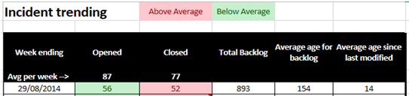

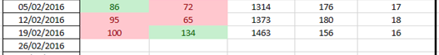

**Table 1.** Open and Closed incidents trend table comparison to 2014 (internal, 2016)

Table 2 shows another set of current data (internal, 2016) and again first row was compared to week 24 October 2014. It is noticed that a significant number of incidents logged in by customers were increasingly set to Critical. Critical is only used for when the system is down and no users have access to it. A lot of incidents were not of this nature so were dropped to Medium in majority of these cases.

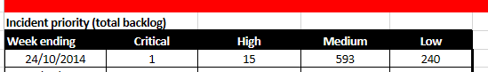

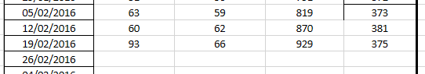

**Table 2.** Levels of Priority incidents trend table comparison to 2014 (internal, 2016)

The next graph, Figure 10, is based on the incident’s Status Reason (internal, 2016). The graph demonstrates the three most common status reasons. This is crucial as this affects the SLAs.

They are:

* ‘NEW’: always when incident come in, it is at this status first, then
* ‘In Progress’: when it is assigned to a team member
* ‘Waiting For Customer’: waiting for response from customers

The SLA is advancing when the status is set to ‘In Progress’. The SLA pauses when the status is set to ‘Waiting For Customer’, while awaiting for the customer to reply. When customer updates the incident, the status changes back to ‘In Progress’ and the SLA kicks in again.

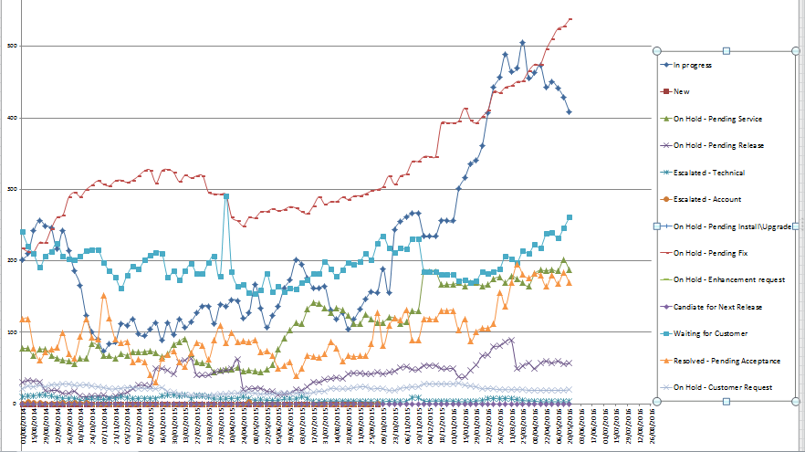

**Figure 10.** A number of Status Reasons listed for the stage an incident is at (internal, 2016)

I noticed when I took data from the earlier years (2014) to the current date the level of incidents had increased significantly.

The reasons behind this are based on a number of factors:

* Staff shortages
* New contracts created*
* Launch of new products*
* Upgrade and installation of new versions*

*These are resulting in new as well as existing customers raising incidents with the company.

The above are also causing the incidents not being resolved as it should be within the agreed SLA timeframe. They are:

* In Progress – not moving for a while so the whole incident becomes a communication issue in terms of how old this incident is (see under How Data Is Taken heading in this chapter).
* On Hold … - these stay for anything up to two years as the future release of version is not ready for release (that is, not signed off for deployment plan).

From the current support team, I took overall data of our team’s incidents workload. My aim is to look at the support team as a whole and see what changes within the team might have impacted the trends of the incidents. Below are two tables – Table 3 and Table 4. Table 3 is showing the two areas that are specific to this project taken from 2015 (internal, 2015) in comparison to Table 4 showing in 2016. Interestingly, the column “Average days # since last communication” shows the incidents are delayed from being resolved (internal, 2016).

The data I evaluated are the two incident metrics required to meet the project’s objective:

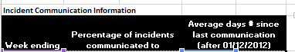



**Table 3.** Two areas of the project’s aim and objective (internal, 2014)



**Table 4.** Two areas of the project’s aim and objective (internal, 2016)

**MIDWAY STAGE OF DATA ANALYSIS**

Midway stage from beginning February to beginning May 2016 of, data analysis and the communication gap, have still not met each other. We have recruited new staff and training is in place. New contracts have been created so more customers. A number of warehouse job load for migration have been scheduled during this period. Also new version for a product has now been scheduled to be deployed. Figure 11 (internal, 2016) and Table 5 (internal, 2016) both show the pattern of the incidents midway and not a huge significant change.

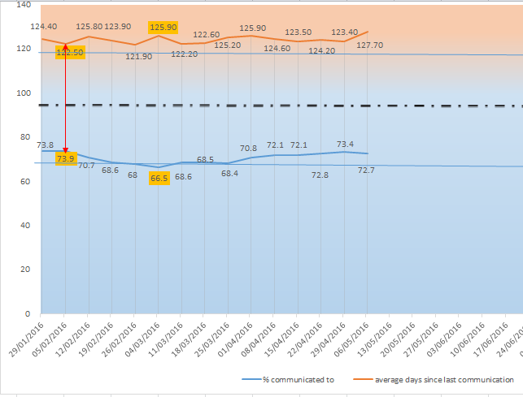

**Figure 11.** Midway graph pattern trend (internal, 2016)

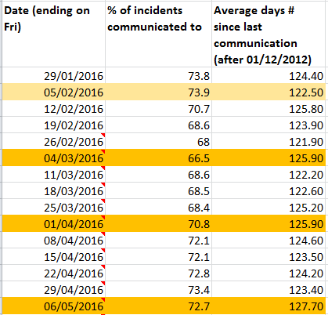

**Table 5.** Midway data (internal, 2016)

**END STAGE OF DATA ANALYSIS**

Towards the end of May, more staff have been recruited and trained since the last analysis was taken. Figure 12 (internal, 2016) and Table 6 (internal, 2016) both show the pattern of the incidents at a later stage. It is starting to show a closing gap between the two lines. Incidents are being chased up and those auto-resolved which did not close off after ten days are being resolved or manually closed off by me. There was a bug in the CRM where this was not closing off automatically.

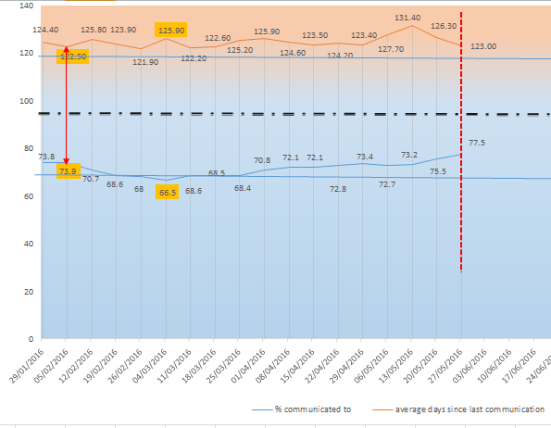

**Figure 12.** Trends Analysis of Communicated Incidents (internal, 2016)

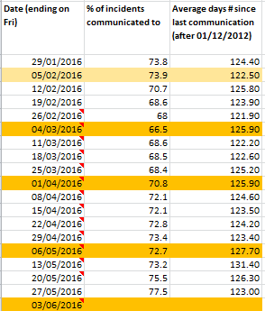

**Table 6.** End of data (internal, 2016)

Figure 13 shows statistics collated at the three stages of project. Although the current stage is further than the midway stage this gives a better picture to look at the pattern trends (internal, 2016).

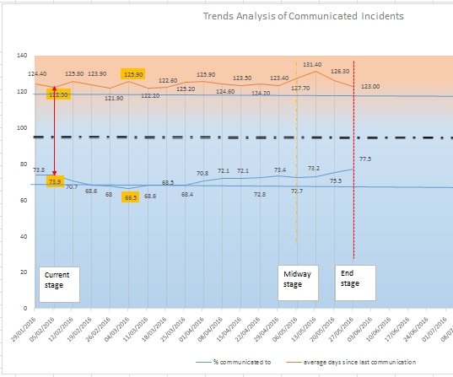

**Figure 13.** Final project analysis (internal, 2016)

**TEAM STATISTICS**

The current statistics, Figures 14 to 19 collated from the support team based on 1,071 active incidents (dated 23 May) are demonstrated in the following graphs, in various data resources.

* Figure 14 shows the incidents in its current state and as expected, the majority would be In Progress followed by Waiting For Customer (internal, 2016).

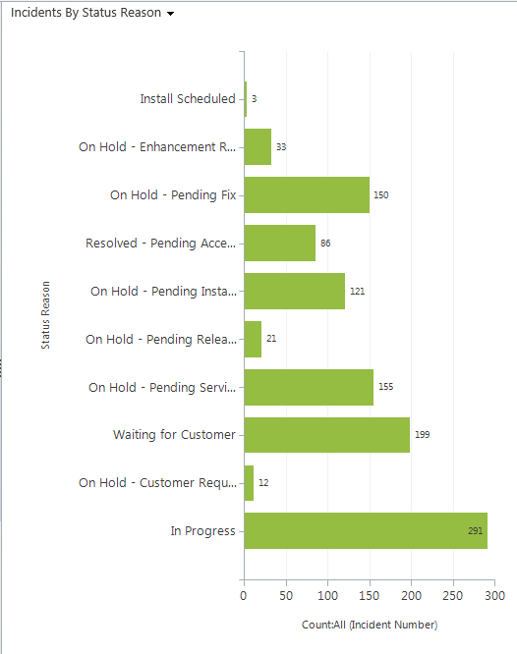

**Figure 14.** Incidents By Status Reason (internal, 2016)

* Figure 15 highlights the priority of each incident by each team member. Medium is the most common priority followed by Low (internal, 2016).

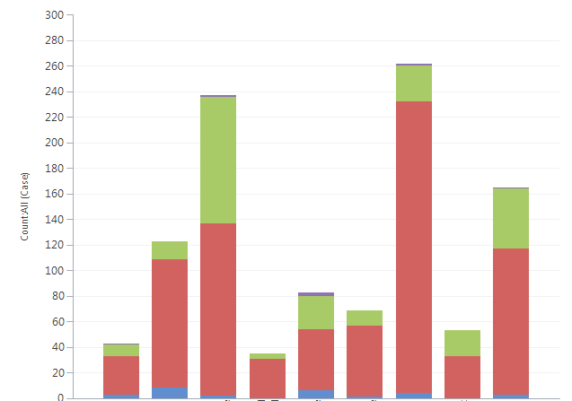



**Figure 15.** Cases by Priority (internal, 2016)

* Figure 16 are the number of incidents sent in by each account. They each have their Membership levels account in Gold, Silver or Bronze. This is crucial as it affects the SLAs when dealing with their incidents (internal, 2016). Who they are is irrelevant but it is the figures for some of the accounts held on incidents. 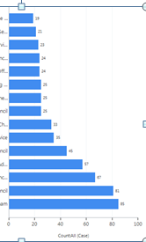

**Figure 16.** Incidents By Customer (internal, 2016)

* This brings on the next Figure 17 (internal, 2016) where 456 incidents not closed off in June will all be in breached by SLAs.

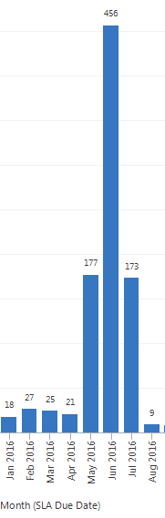

**Figure 17.** Incidents Approach SLA Breach (internal, 2016)

* Figure 18 shows the incidents assigned to individual team member of the support team. I had 69 “My Active Cases” incidents which means they are Open incidents, waiting to be worked on and closed off.

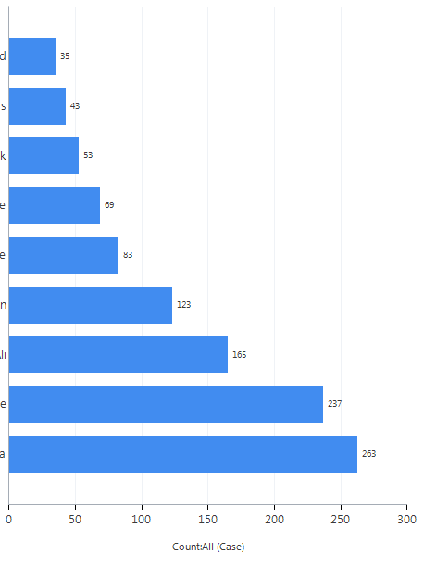

**Figure 18.** Service Leaderboard (internal, 2016)

* Figure 19 shows the types of incidents that come in and the majority being Service Request, followed by Bug and Customer Issue, (internal, 2016)

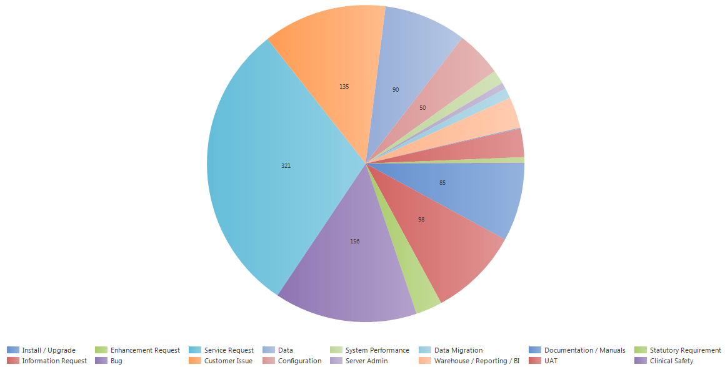

**Figure 19.** Case Mix, By Type (internal, 2016)

**IMPACT ANALYSIS ON THE BUSINESS**

The effect of the increasing high volume of incidents is resulting in repercussions to the company. The trends of the impact are usually at the start of the incident logged in which tends to be related to the following: installs, upgrades, release versions, pre-SLA application issues and items which are unrelated to company. These are threats to the business that require to be examined for future forecast, as well as considering that:

1. Agreed SLAs not met are unrealistic and should be reviewed.
2. Customer dissatisfaction and defection to alternative company.
3. Running a number of projects between one to three years. This results in high expectations and impacts profits.
4. Staff shortages increase workload for current staff – under pressure - require more recruitment.
5. Review better Partnerships - third parties such as ICT, IT dept, YJB, i2n.
6. SLA which is the start of the whole Incident Management process. Risk Assessment of the Incident Severity Level: Review SLA - Critical incident to turnaround on this issue within three hours; High – a day; Medium – 5 days and Low – fortnight. Or three months even when logged in as Critical. The increase of 60+ Critical incidents is not following correct SLA.
7. Review of accounts and be transparent with achievable resolution aims: Gold members, Silver members and Bronze members.
8. Recruit a Business Analyst to present to company research, facts and figures.
9. Contract is in the form of an SLA. It is time to reflect and realise the demand of software solutions and supply to not just the local authorities but those within the segments part of the community social care aspect – this is where the increasing number of customers logging in causing an increasing overflow of high % of incidents that probably could be sorted onsite:

* attended training
* refer to the manuals that is available to them through the self-service portal
* check with their own IT department
* check with their local ICT

1. Reputation of company will turn away renewable contracts especially where customers work in partnerships with other local authorities.
2. Financial burden if customers look for alternative company.
3. Stand unique – do not be competitive offering bonuses to staff based on performance.
4. Be transparent - business objectives plan and clear systematic open communication with policies and procedures.

**RECOMMENDATIONS**

**FOR IMPROVEMENT OF INCIDENT TREND ANALYSIS**

1. Look at the SLA – see who looks after what.
2. SLA will need to be reviewed as the deadline pressure is mounting up on those who cannot guarantee they can meet the incident within the agreed SLA timeframe (there are numerous incidents that have already been breached but no-one seems to be too concerned).
3. Consider the type of incidents that are raised.
4. Consider the common factors such as people or type.
5. Options – training/refresher training.
6. Representative Lead onsite who is of IT background. This resource will have an expertise in CRM and CareWorks Products.
7. Representative Lead to identify incidents before logging them.
8. Start charging if they do not read manuals or training materials.
9. A lot of issues like ‘How would I know if the report is the latest version of the report in the warehouse?’, can be answered by the Representative Lead and not in the incident to the company.
10. When users have different URLs to the company, changing the name to make it ‘user friendly’ is resulting in more problems and incidents being raised.
11. A checklist for customer to ensure they have checked the following within the manual including ‘You may have an upgrade due – find out before logging in incident as you might have to wait for this in order to use the software’.
12. A checklist for Representative Lead that customer has checked the checklist and the Lead has checked any changes made to the training manuals or to the software applications.
13. Need more staff on the Frontend ground level – support team.
14. Support team to be communicated to with lots of updates via team daily meetings.
15. New staff recruited into support team need consistent regular contacts and communications to ensure they are following the flowcharts and systems especially the follow ups (3 stage review).
16. To identify a batch of similar incidents and work as a pair to go through troubleshooting this in order to send them all the same answer where applicable, resulting in several incidents being closed.
17. I should present any ideas and suggestions to the team and implement them to an agreed standard. A lot of these incidents are relating to hardware issues like server, monitor screen (resolution) and to the software applications.

**CHAPTER 4 MINI PROJECT- CONCLUSIONS AND RECOMMENDATIONS**

**CONCLUSIONS**

My role was to resolve as many incidents as possible. As an Intern coming in as first line with no frontend customer service skills is probably not a good place to start as incidents are left behind, allowing the build-up, and no-one is monitoring the Intern. This is due of lack of knowledge and understanding of addressing customers, dealing with incidents, SLAs, priority, communications, steps to replicate IT issues. It is a better approach to introduce the Intern to using software products and replicating the steps, for three months. Afterwards, expose them to frontend customer service level as they will be more aware of incident types and can deal with them when familiar with the product, version and issue. It is crucially important to understand the products first and foremost.

With new team members, meetings are crucial to update, review, clarify and also identify any request for learning needs.

Also a peer to peer session to be allocated a time in the week in order for an experienced member of staff to guide a non-experienced member of staff in identifying and resolving commonly raised incidents and to test their knowledge into subjects such as which Release Note to look at for this issue. Due to time constraints, as the experienced member of staff could not guide the Intern into resolving Incidents, this resulted in the incident not progressing and the SLAs not being met. This increased the communication gap.

As a result of this process, I will know how to eliminate and report back the common incidents that are coming in. Most of them were irrelevant and so at this time of Chapter 1 my recommendation remains that it would be a case of training for a lot of these customers onsite. When an upgrade of the application took place, a plugin or fix needs to be implemented. Due to a change to the application this resulted in customers being unfamiliar with the new version. Mandatory refresher training was provided by the training consultant then this would have eliminated any misunderstandings.

**RECOMMENDATIONS**

* Basic ground rule - check SLA agreement. See who looks after what.
* A Representative Lead, who would have IT background, would be present on the client’s premises. The Representative Lead would decide on priority level and can identify incidents quickly. They could involve IT department to address issue and if all else fails, (using a checklist), then raise the client’s issues as incidents.
* The Representative Lead ensures that any changes are carried out against new contact or training information in **Manuals**, via self-service portal.
* Manuals should include FAQ – common questions and queries from other users. Some users log incidents rather than referring to Manuals.
* Before raising an incident, the client would refer to a Checklist. This checklist would contain a number of entries, such as ‘How to take a screenshot’ and ‘How to use a PSR’.
* Incidents with a status of ‘Waiting for Customer’, means that further information is required from the client, who has not responded. An email should go to the Representative Lead who raised the incident saying that person did not reply and the incident has been closed off.
* Incidents raised would be of more relevance and would be more efficiently dealt with, thus closing the communication gap.
* Daily update meetings.
* Offer short term training programmes – on common issues.
* Define specific roles and responsibilities and assign a cross over as backups as part of training and own personal development plan – this will allow knowledgeable experienced teams, more recruitment and retention in the company.
* Customer’s checklist – they have checked their local IT, ICT at their end

**OTHER FURTHER RESEARCH AND INVESTIGATION**

I completed the mini project within the deadline period for college but I also had time to start on this project when I started my work placement at the beginning of February. The project around the patterns of the analysis really needed to engage a much earlier picture of the current state then to view it again midway and before I leave the internship.

I was able to interpret the trends. I analysed why the gap was larger than it should be and what the cause is. The wider communication gap was caused at the time of staff changes so new staff could not deal with incidents straight off. The Support Team had lost two team members and I did not have any skills on the frontend. In addition, 280+ incidents that were ‘In Progress’ status were split between two team members. The resource that left the company had more experiences on the frontend role. I was in the process of understanding a number of issues, such as different products and versions. I became aware of the SLA as well as critical and high priority incidents.

Any IT industry always starts off at the Service Desk root. Spend two years at this level to get the ground work of basic IT knowledge and understanding.

Then branch off into other areas where the person can build up on furthering their IT skills:

* Implementation
* Development
* Management
* Analyst

**GLOSSARY**

CMMI Capability Maturity Model Integration: A process-based approach to help organisations to use best practices for performance improvement.

i2n: Company sends email to them and i2n set up a connection to the application and database servers with customer and Company.

ICT: Information and Communication Technology – provide a unified communication/ convergence of networks communication.

IT: Information Technology – customer discuss with own IT department in case they were doing something on site.

PSR: Problem Steps Recorder – Microsoft recording tool.

SLA Service Level Agreement: An agreement between IT Department (as well as company) and customer based on operational services (business hours/days) and what services are provided.

SQL Structured Query Language – database queries for outcome results.

TCP: Transmission Control Protocol- in TCP/IP networks. Enables two hosts to establish a connection – then send/receive data. TCP guarantees packets arrived in same order as sent.

YJB: Youth Justice Board internal who works with i2n on connectivity issues.

APPENDICES

**APPENDIX i.**

**MINI PROJECT PROPOSAL – OPTION 1**

**Aim:** **To meet CareWorks’ Business Analysis strategically**

**Objective: To recognise types and identifying incidents trend patterns**

During my meeting with the manager to go over my level of internship learning role, he made a suggestion that they would need someone to do this main area of concern. He thought I could do this task as a project for my college as well. If this case was approved then he would support me 100% all the way. I would have access to all the analysis metrics. They require a new project to be carried out on analysing data and interpreting how this could be improved for the organisation. I am given authority to take current snapshots and throughout different stages to inform myself of investigating into the increase volume of incidents and high percentage of incident types. And the no of incidents according to the Gold Support level priority, along with Silver and Bronze. This information would help the organisation to address and identify any issues that could cause an impact on their business and their business processes. I will use various resources such as direct observations within my role as first level support desk; interviews with team members and maybe with other departments; develop or amend the protocols and or procedures refer to Sharepoint (company’s shared documents). The project will outline a depth and knowledge of incidents on software and hardware issues via incidents. It is appropriate to my IT Management degree programme – such as Customer Relationship Management (CRM) and ITIL framework as well as networking and software applications areas.

I will shadow staff when dealing with different incident that is not common. I will refer to Manuals and any other Documentation and update these. The software products are many and from each product are many versions so not everyone is top of game. I hope if time to identify these and do flowcharts. I may just initiate a number of pseudocode flowcharts so that it is easily recognisable for another new staff or intern to come in and just visualise what is what and where does everything sit. Evaluating whilst updating incidents data on excel the level of open, closed and resolved incidents that have increased. I will be using through the Customer Relationship Management (CRM) how to identify the type of incidents that are logged in. Can they have been resolved at the customer’s end rather than logged in an incident with us? I will in stages do the following requirements: do the analysis; help to clean up the incidents to as low as possible; continue with ongoing work on incidents; identifying what remained consistent and what did not; make recommendations on improvements and suggestions made to keep incidents reduced to; and then a projection to see the future of how this pattern remains – any impact on the company in the future. The idea is to look at the weekly metrics on various areas of the incidents and interpret what they are saying.

I will be creating the weekly reports at the end of each week, Friday near end of the day.

I will look at the metrics and interpret what they are saying

I will then have to work to change the trends in the analysis report

I will envisage communicating replies to customers’ requests in order to close off the incidents as soon as possible or request further information. I will see if this gets through clearly to avoid another set of questions under the same incident or log in with another.

My remit would be to sweep up the incidents after the team members especially one with the highest backlogs. Consider the dangers of spoofing.

I will have to look at escalated incidents too and figure out how best to identify the escalated incidents that need a communication

If the escalated incidents are no longer a priority they should be unflagged for escalation or closed off.

I should present any ideas and suggestions to the team and implement them to an agreed standard.

A lot of these incidents are relating to hardware issues like server, monitor screen (resolution) and the majority of the incidents are relating to the software applications. These hardware issues are often related to products and versions of which I hope I will be accustomed to although there are many to remember by the time my seven months internship is up.

I have to think of any suggestions how to change the trends and make these in my recommendation report.

If this mini project proposal is not approved the manager has another up his sleeve that he would be happy to put to me after any rejection!

**APPENDIX ii.**

**INDUCTION PLAN FOR INTERN**

**FOR BETTER LEARNING AND COMPLETION**

|  |  |  |  |  |
| --- | --- | --- | --- | --- |
| Month 1 | 2 weeks | Interviews | 2 weeks | Shadowing |
| Complete competencies for most  Set up on new accounts with remote access and ensure VMs are installed  Solid work start on the applications and servers … recognising what to expect when issues come in and learn to troubleshoot and recognise if it’s a bug or not – Release Notes; Customer Self Service Portal | | | |
| Month 2 |
| Month 3 | Set aside one half day a week for 3 weeks on project at work  Increase to a day the next 3 weeks  Include presentations at work | | | |
| Month 4 |
| Month 5 | Service Desk role | | | |
| Month 6 |

**APPENDIX iii.**

BUSINESS PROCESS ANALYSIS AND IMPROVEMENT STRATEGY PLAN 2016

PROJECT KEY OBJECTIVES

|  |  |  |  |  |  |  |  |
| --- | --- | --- | --- | --- | --- | --- | --- |
| **Employee Name:** Ramona Valentine  **Line Manager Name:** Aidan Swords | | | **Performance Period**  **From: 1st Feb 2016 To: 26th Aug 2016** | | | | |
| **Objective 1:**  **To identify and interpret incident trends through data and graphs collated for reports and presentation/project.**  **Collate current graphs and data to start off – 1st Feb 2016**  **Then view it as it stands against other statistical analysis** | **Measures of Success**  1 All-non closed incidents  Incident Metrics  Status of Reasons  Support Team individual incidents open and reasons  From weekly report emails | | | | **Due Date**  **Review weekly**  **Snapshot end of each month**  **End 26th Aug 2016**  **Weekly Fridays**  **End 26th Aug 2016** | Other Staff  Aidan (lead)  Level 1  Level 2  Senior key | |
| **Update: (Quarterly: Employee and Line Manager)** | | | | | | | |
| Objective 2:  **To interpret and report current graphs and data FOR WAKEFIELD account only**  **Then view it as it stands against other statistical analysis – 1st March 2016** | | Measures of Success:  1 All-non closed incidents  Incident Metrics  Status of Reasons  From weekly report emails | | Due Date  31st March 2016  (one month only) | | | Other Staff  Aidan  Emer |
| Update: | | | | | | | |
| **Objective 3:**  **Additional tasks set by support manager to understand CRM and use of pulling data from queries either in CRM and or Excel** | | **Measures of Success:**  **Advanced Find / Filter – CRM**  **Excel – use Pivot Table** | | **Due Date**  **Weekly Thursdays (Review meetings)**  **Then increase to 2-weeks, subject to review** | | | Other Staff  Aidan |
| **Update:** | | | | | | | |

|  |  |  |  |
| --- | --- | --- | --- |
| Objective 4:  From Objective 1, identify ways to improve and reduce number of incidents and recommendations for business to improve in its future projection | Measures of Success:  At end of weekly reports on Fridays write up a 3-4 bulletpoints and then use this to build a picture of pattern and make recommendations | Due Date  End of May for college  End of Aug for work | Other Staff  ITT  Aidan |
| Update: | | | |

**APPENDIX vi.**

PERFORMANCE PLAN AND REVIEW

|  |  |  |  |  |  |
| --- | --- | --- | --- | --- | --- |
| **Type of Review:** | **Probationary ✓ Quarterly Annual** | | | | |
| **Employee Name:** Ramona Valentine | | | | | |
| **Team:** Support Team | | | **Performance Period**  **From: 1st Feb 2016 To: 26th Aug 2016** | | |
| **Line Manager Name:** Aidan Swords | | | | | |
| **Evaluated By:** Aidan Swords | | | | | |
| **Last Review Date:** First New | | | | | |
| **Objective 1:**  To gain knowledge and skills undertaking tasks and duties in own role within the IT industry through work placement by completing as many competencies, by end May 2016 | | **Measures of Success**  Draw up competencies table with margins for key named person and topic or area  Meet Manager and go over this checklist of competencies and discuss  Identify key staff to meet and to participate in | | **Due Date** | **Weight (%)** |
| **Update: (Quarterly: Employee and Line Manager)** | | | | | |

|  |  |  |  |
| --- | --- | --- | --- |
| Objective 2:  To identify two initial project proposals, 600-800 words each, for upload and decide which one for mini-project completion, by end of May 2016 | Measures of Success:  Discuss with Aidan, CareWorks   1. Incidents Trends – duty focused around this all the time   Own option   1. Research into hearing equipment for deaf relating to headphone set at work   Upload to Patricia, ITT  ITT/Patricia approve mini-project option  Start mini-project  End / upload by | Due Date  19th Feb  18th Feb  Draft 22nd Feb  Upload 26th Feb  Meeting 11th March  11th April  27th May | Weight (%) |
| Update: | | | |
| **Objective 3:**  To complete requirements for Project Report and processes by following own timetable_Project timeline and words limit and tick off each item with uploaded own time and ITT upload due date, by end of June/Sept 2016. | **Measures of Success:**  Mini project proposals  Feb Bi monthly report  Mini project proposal meeting (approval)  Chapter 1 section  Chapter 2 section  Start on mini-Project to end  April Bi monthly report  Mini project progress report  June Bi monthly report  Chapter 3 section  Chapter 4 section  Final Project Report  Oral Project Presentation  Oral Presentation (including employers) | **Due Date**  26th Feb  6th March  11th March  16th March  8th April  11th Apr-27th May  1st May  4th May  From 14th May  27th May  3rd June  3rd June  9th June  2nd Sept | **Weight (%)** |
| **Update:** | | | |

|  |  |  |  |
| --- | --- | --- | --- |
| Objective 4:  To achieve a better understanding of how the organisation works in terms of IT by 26th Aug 2016 | Measures of Success:  CareWorks work placement (seven months)  Review / feedback from both (me and CareWorks) | Due Date  26th Aug  26th Aug | Weight (%) |
| Update: | | | |

**APPENDIX v.**

**PROJECT PRESENTATION SLIDES**

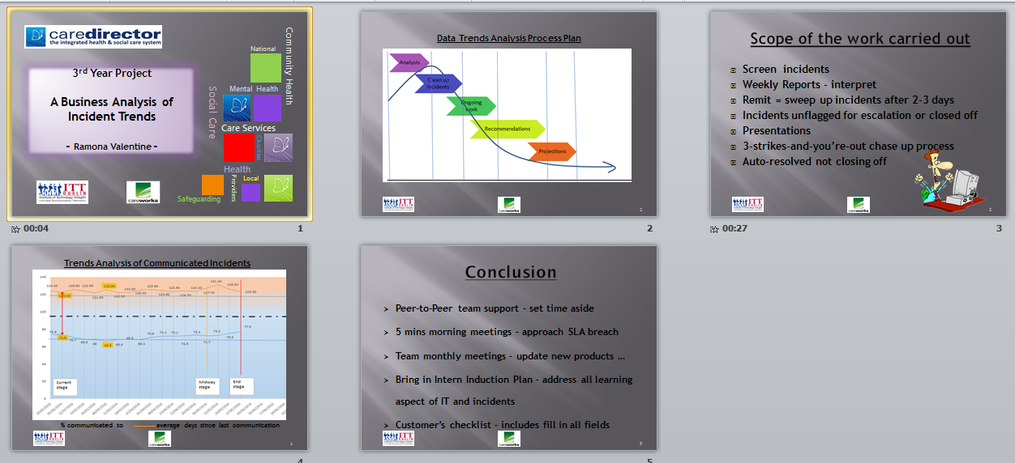

*(Subject to Change)*

|  |  |
| --- | --- |
| **APPENDIX vi.**  **SWOT** | |
| **STRENGTHS**  Competent using excel and room to improve!  Time manage workload  Confident to chase up or follow up incidents  Confident to inform/check/ask staff on IT and incidents’ issues  Transferable skills such as objective plans, project plan, SWOT (as this), typing, File management, Office365, Skype, excel (especially for graphs and data formulas), time management, communication skills  Project Management skill  Presentation skill | **WEAKNESSES**  Not using headphone set equipment  No experience on front desk customer service  No experience on use of MS Dynamic CRM |
| **OPPORTUNITIES**  Learning how to use MS Dynamic CRM  Learning how to word things to customers  Understanding SLA clocking on and off  Interpreting and analysing data and graphs to report  Learning ITIL  Using SQL queries  Using and carrying out main IT skills – eg. restore/backup/URLs/remote access/connectivity/ etc  Recognising where servers sit and operate as  Learning priority of incidents  Learning 3 steps review to follow up incidents and to close off  Weekly Contracts and Weekly Incident Reports  Understanding roles of Implementation, Engineer, and Development to see where I fit in – Backend is preference | **THREATS**  Not being able to communicate with customers over phone  Not being able to participate in teleconferencing  Not being able to be trained up on staff training via teleconferencing  Stuck at Frontend duty/role (even if moving to new job) |

**REFERENCES**

Carmody, Lorraine (2014) *Lecture Notes* [Coursework handouts] October 2014

CareWorks, *Company*  (2015) [Online] Available from: <http://www.careworks.co.uk/company> [Accessed 7 February 2016]

Dolan, Michael (2016) *Interview meeting* [internal source] March 2016

Optimize Smart, *Google Universal Analytics Data Trend Analysis – Complete Guide* (2011) [Online] Available from: <https://www.optimizesmart.com/analyze-interpret-report-data-trends-google-analytics/> [Accessed 2nd May 2016]

Van Bon, J., Pieper, M. and van der Veen, A. (2015). *Foundations of IT Service Management, based on ITIL.* 2nd edition*.* Netherlands: Van Haren Publishing, pp. 43-55, 57-62

**BIBLIOGRAPHY**

Academy of Management Journal Volume 57 Number 2 April 2014 “The Impact of Social Context on the Relationship Between Individual Job Satisfaction and Absenteeism: The Roles of Different Foci of Job Satisfaction and Work-Unit Absenteeism” Stefan Diestel, Jurgen Wegge, and Klaus-Helmut Schmidt pp 353

Axelos Global Best Practice, *IT Service Management (ITIL)* (2014) [Online] Available from: <http://www.axelos.com/IT-Service-Management-ITIL/> [Accessed 7TH February 2016]

Benyon, Robert and Johnston, Robert (2006), *Service Agreements – A Management Guide.* Netherlands, Van Haren Publishing.

Chartered Accountants Ireland (2009), *Information Management Principles,* Ireland, Chartered Accountants Ireland.

CMMI – v1.3 (2010) For Services - Under CMMI I am looking at the Optimizing of the Maturity Level which covers the Process Areas of Causal Analysis and Resolution as well as Organisational Innovation and Deployment

CMMI <https://sas.cmmiinstitute.com/pars/>

Control Objectives for Information and related Technology (CobiT)

EFQM, *The EFQM Excellence Model* (2014) [Online] Available from: <http://www.efqm.org/the-efqm-excellence-model> [Accessed 7th February 2016]

FINEOS, *FINEOS Claims – Measurable Results* (2011) [Online] Available from: <http://www.fineos.com/about/why-fineos/> [Accessed 7th February 2016]

Google Universal Analystics Data Trend Analaysis – Complete Guide – Himanshu Sharma 2012

Heller, Robert (1998), *Essential DK Managers -* *Making Decisions.* London: Dorling Kindersley Limited.

Hub PM, *Brief Definitions & Differences Between CCMI vs ITIL* (11th May 2013) Nayab, N [Online] Available from: <http://www.brighthubpm.com/monitoring-projects/72298-differences-in-cmmi-vs-itil/> [Accessed 7th February 2016]

Information Technology Infrastructure Library (ITIL)

Information Technology Services Capability Maturity Model (ITSCMM)

International Journal of Technology Management publisher: Inderscience Enterprises Ltd, Switzerland Volume 58 Numbers 1-2, 2012 “The Relationship between sustainable business management and competitiveness” pp 34-41

ISO/IEC 20000: Information Technology – Service Management

ITIL, *Welcome to the Official ITIL website* (Sunday, October 12, 2014) [Online] Available from: <http://www.itil-officialsite.com/> [Accessed 7th February 2016]

Lemieux, Rick (2008), *ITIL's IT Service Lifecycle - The Five New Silos of IT* [Online] Available from: <http://www.itsmsolutions.com/newsletters/DITYvol4iss01.htm> [Accessed 7th February 2016]

McNurlin, Barbara C. and Sprague, Ralph H. Jnr (2006), *Information Systems Management in Practice*,7th edition. New Jersey: Pearson Education, Inc.

NHS England, *sla* *Template service level agreement (SLA) for CCGs published* (5th November 2012) [Online] Available from: <https://www.england.nhs.uk/tag/sla/> [Accessed 7th February 2016]

NHS SLA (8th July 2013) [Online] Available from: <http://www.professionalsecurity.co.uk/news/health/nhs-sla/>[Accessed 7th February 2016]

Pears, Richard and Shields, Graham (2010), *Cite Them Right – The Essential Referencing Guide*. 8th edition. Hampshire: Pulgrave MacMillan.

Queensland Governement https://www.business.qld.gov.au/business/running/risk-management/risk-management-plan-business-impact-analysis/treat-risks-business

Strategic Management Journal Publisher: Wiley-Blackwell Volume 34 Number 1 January 2013 “The Impact Performance Relative to Analyst Forecasts and Analyst Coverage on Firm R&D Intensity” RJ Gentry and W Shen

Technology Analysis & Strategic Management Publisher: Routledge Volume 21 Number 8 November 2009 “Special Issue Impacts and implications of future oriented technology analysis (FTA) for policy and decision-making” by Ozcan Saritas, Cristiano Cagnin, Attila Havas and Ian Miles p915

TechTarget, http://searchdisasterrecovery.techtarget.com/feature/Using-a-business-impact-analysis-BIA-template-A-free-BIA-template-and-guide

Verint (2014) *Customer Engagement Optimization* [Online] Available from: (<http://www.verint.com/solutions/index.html> [Accessed 7th February 2016]